VISUALIZATION OF DATA SETS
Scientific Visualization:
The use of graphical methods as an aid in scientific and engineering analysis
For example, dealing with the output of high-volume data sources such as supercomputers, satellite and spacecraft scanners, radio-astronomy telescopes, and medical scanners.
Visualization techniques are useful for analyzing processes that
occur over a long time period
cannot be observed directly
Such as
quantum-mechanical phenomena
special-relativity effects produced by objects traveling near the speed of light
To visually display, enhance, and manipulate information to allow better understanding of the data, Scientific visualization uses methods from
computer graphics
image processing
computer vision
Business Visualization
Visualization methods employed by commerce, industry

Data Set Classification
Data sets are classification according to
Their spatial distribution
Data type.
Two-dimensional data sets have values distributed over a surface
Three-dimensional data sets have values distributed over the interior of a cube, a sphere
Data types include scalars, vectors, tensors, and multivariate data.
Visual Representations for Scalar Fields
A scalar quantity is one that has a single value.
Scalar data sets contain values that may be distributed in time, as well as over spatial positions.
The data values may be functions of other scalar parameters.
Some examples of physical scalar quantities:
energy density mass temperature pressure charge resistance reflectivity frequency water content
A common method for visualizing a scalar data set is to use graphs or charts that show the distribution of data values as a function of other parameters, such as position and time.
If the data are distributed over a surface, we could plot the data values as vertical bars rising up from the surface, or we can interpolate the data values to display a smooth surface.
Pseudo-color methods are also used to distinguish different values in a scalar data set, and color-coding techniques can be combined with graph and chart methods.
To color code a scalar data set, we choose a range of colour and map the range of data values to the color range.
For example, blue could be assigned to the lowest scalar value, and red could be assigned to the highest value.
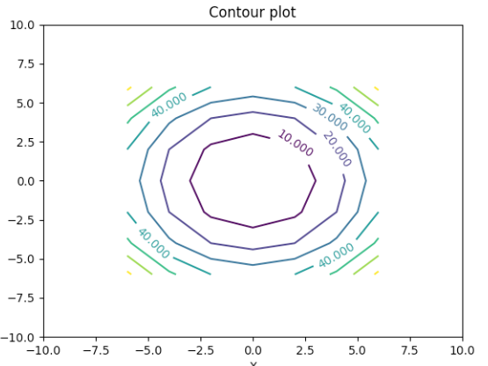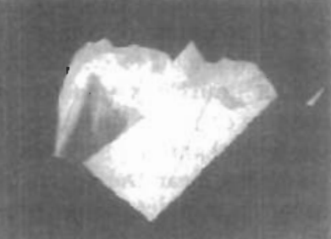
However, some color combinations can lead to misinterpretations of the data.
Contour plots are used to display isolines (lines of constant scalar value) for a data set distributed over a surface.
The isolines are spaced at some convenient interval to show the range and variation of the data values over the region of space.
A typical application is a contour plot of elevations over a ground plane.
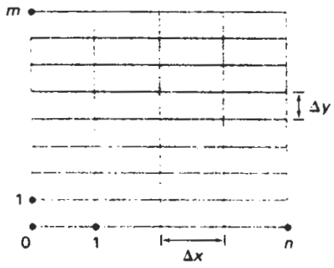
Contouring methods applied to a set of data values that is distributed over a regular grid
Regular grids have equally spaced grid lines, and data values are known at the grid intersections. Numerical solutions of computer simulations are usually set up to produce data distributions on a regular grid, while observed data sets are often irregularly spaced.
Contouring methods have been devised for various kinds of nonregular grids, but often nonregular data distributions are converted to regular grids.
A two-dimensional contouring algorithm traces the isolines from cell to cell within the grid by checking the four corners of grid cells to determine which cell edges are crossed by a particular isoline.
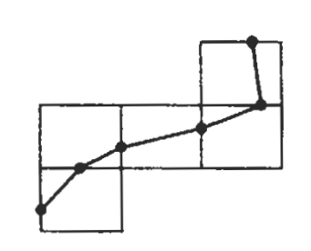
Isolines plotted as straight-line sections across each cell
Sometimes isolines are plotted with spline curves, but spline fitting can lead to inconsistencies and misinterpretation of a data set.
For example, two spline isolines could cross, or curved isoline paths might not be a true indicator of the data trends since data values are known only at the cell corners.
Contouring packages can allow interactive adjustment of isolines by a researcher to correct any inconsistencies.
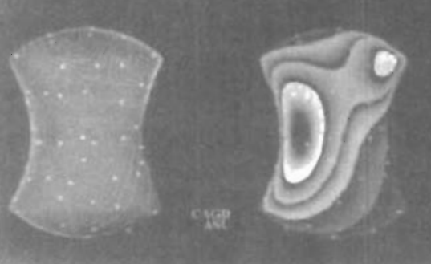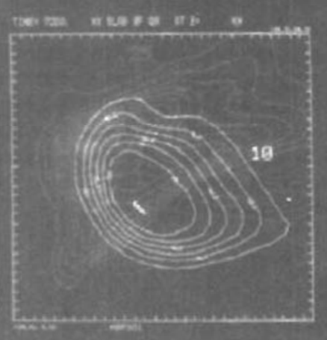
Contour lines and color coding for an irregularly shaped space.
For three-dimensional scalar data fields, we can take cross sectional slices and display the two-dimensional data distributions over the slices. We could either color code the data values over a slice, or we could display isolines.
Visualization packages typically provide a slicer routine that allows cross sections to be taken at any angle.
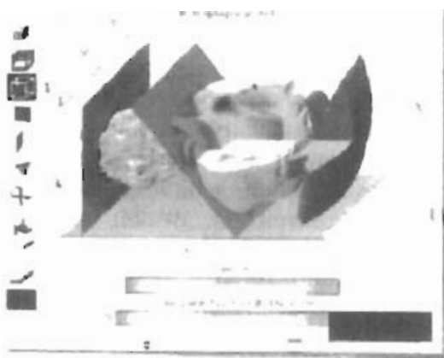
Slicerdicer package.
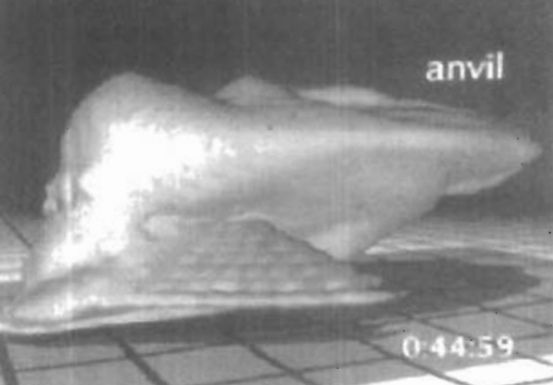
Three-dimensional contour plots IsoSurfaces
When two overlapping isosurfaces are displayed, the outer surface is made transparent so that we can view the shape of both isosurfaces.
Constructing an isosurface is similar to plotting isolines, except now we have three-dimensional grid cells and we need to check the values of the eight comers of a cell to locate sections of an isosurface.
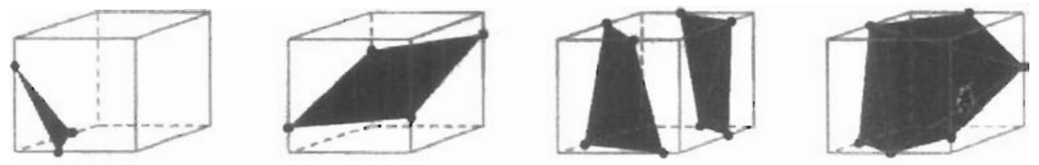
lsosurface intersections with grid cells, modeled with triangle patches
Isosurfaces are modeled with triangle meshes, then surface-rendering algorithms are applied to display the final shape
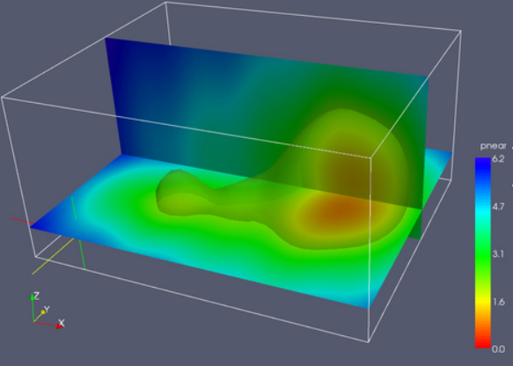
Isosurfaces
Volume rendering, which is often somewhat like an X-ray picture, is another method for visualizing a three-dimensional data set.
The interior information about a data set is projected to a display screen using the ray-casting methods
Along the ray path from each screen pixel, interior data values are examined and encoded for display.
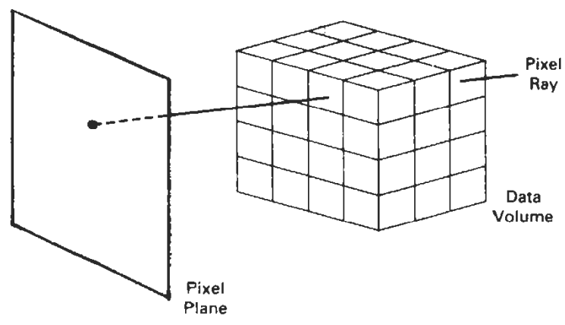
Ray casting to Examine Interior Data Values
Often, data values at the grid positions are averaged so that one value is stored for each voxel of the data space.
How the data are encoded for display depends on the application. Seismic data, for example, is often examined to find the maximum and minimum values along each ray.
The values can then be color coded to give information about the width of the interval and the minimum value.
In medical applications, the data values are opacity factors in the range from 0 to 1 for the tissue and bone layers.
Bone layers are completely opaque, while tissue is somewhat transparent (low opacity).
Along each ray, the opacity factors are accumulated until either the total is greater than or equal to 1, or until the ray exits at the back of the three-dimensional data grid.
The accumulated opacity value is then displayed as a pixel-intensity level, which can be gray scale or color.
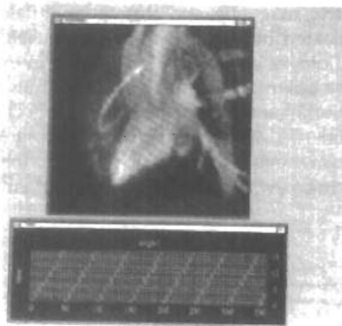
Volume Visualization of Dog Heart.
For this volume visualization, a color-coded plot of the distance to the maximum voxel value along each pixel ray was displayed
Visual Representations for Vector Fields
A vector quantity V in three-dimensional space has three scalar values (V_{x}, V_{y}, V_{z}) one for each coordinate direction, and a two-dimensional vector has two components (V_{x}, V_{y}).
Another way to describe a vector quantity is by giving its magnitude IVI and its direction as a unit vector u.
As with scalars, vector quantities may be functions of position, time, and other parameters.
Some examples of physical vector quantities are velocity, acceleration, force, electric fields, magnetic fields, gravitational fields, and electric current.
One way to visualize a vector field is to plot each data point as a small arrow that shows the magnitude and direction of the vector.
This method is most often used with cross-sectional slices, since it can be difficult to see the data trends in a three-dimensional region cluttered with overlapping arrows.
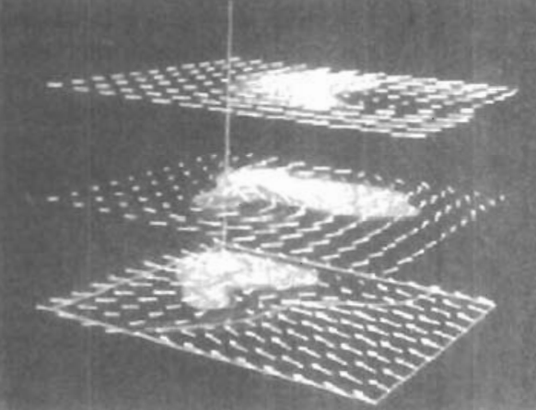
Visualization with Cross-sectional Slices
Magnitudes for the vector values can be shown by varying the lengths of the arrows, or we can make all arrows the same size, but make the arrows different colors according to a selected color coding for the vector magnitudes.
We can also represent vector values by plotting field lines or streamlines.
Field lines are commonly used for electric, magnetic, and gravitational fields.
The magnitude of the vector values is indicated by the spacing between field lines, and the direction is the tangent to the field.
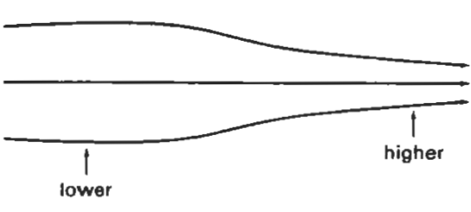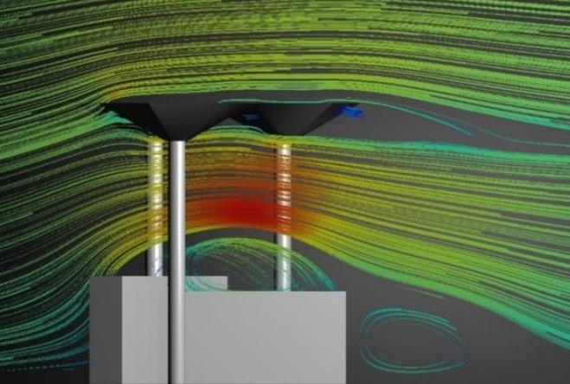
Streamline Plot of a vector field
Streamlines can be displayed as wide arrows, particularly when a whirlpool, or vortex, effect is present. For animations of fluid flow, the behavior of the vector field can be visualized by tracking particles along the flow direction.
Visual Representations for Tensor Fields
A tensor quantity in three-dimensional space has nine components and can be represented with a 3 by 3 matrix.
Actually, this representation is used for a second-order tensor, and higher-order tensors do occur in some applications, particularly general relativity.
Some examples of physical, second-order tensors are stress and strain in a material subjected to external forces, conductivity (or resistivity) of an electrical conductor, and the metric tensor, which gives the properties of a particular coordinate space.
The stress tensor in Cartesian coordinates, for example, can be represented as
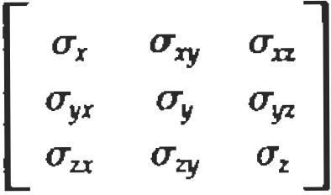
Tensor quantities are frequently encountered in anisotropic materials, which have different properties in different directions.
The x, xy, and xz elements of the conductivity tensor, for example, describe the contributions of electric field components in the x, y, and z directions to the current in the x direction.
Usually, physical tensor quantities are symmetric, so that the tensor has only six distinct values. For instance, the xy and yx components of the stress tensor are the same.
Visualization schemes for representing all six components of a second-order tensor quantity are based on devising shapes that have six parameters.
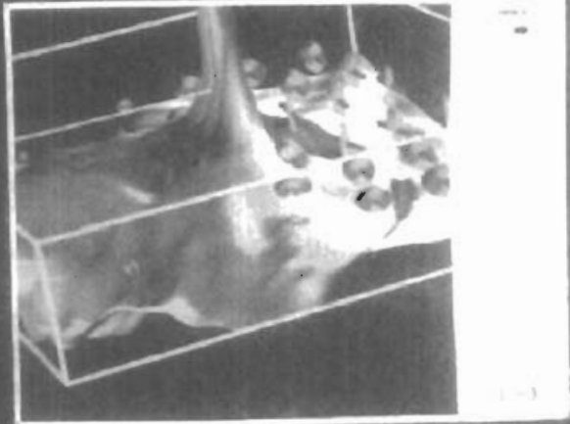
Graphical representation for a tensor
The three diagonal elements of the tensor are used to construct the magnitude and direction of the arrow, and the three off diagonal terms are used to set the shape and color of the elliptical disk.
Instead of trying to visualize all six components of a tensor quantity, we can reduce the tensor to a vector or a scalar.
Using a vector representation, we can simply display a vector representation for the diagonal elements of the tensor. And by applying tensor contraction operations, we can obtain a scalar representation.
For example, stress and strain tensors can be contracted to generate a scalar strain-energy density that can be plotted at points in a material subject to external forces

Visual Representations for Multivariate Data Fields
In some applications, at each grid position over some region of space, we may have multiple data values, which can be a mixture of scalar, vector, and even tensor values.
A method for displaying multivariate data fields is to construct graphical objects, sometimes referred to as glyphs, with multiple parts.
Each part of a glyph represents a physical quantity.
The size and color of each part can be used to display information about scalar magnitudes.
To give directional information for a vector field, we can use a wedge, a cone, or some other pointing shape for the glyph part representing the vector.
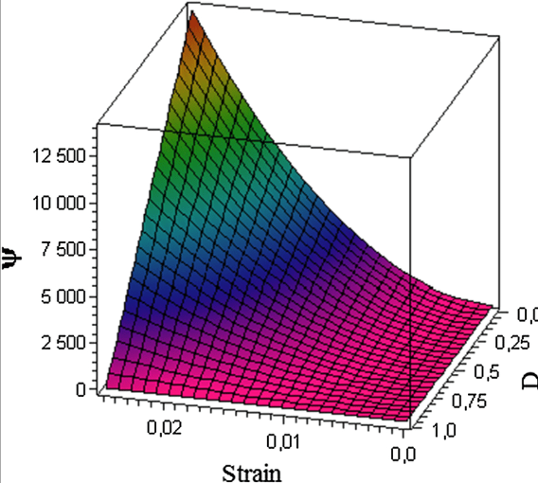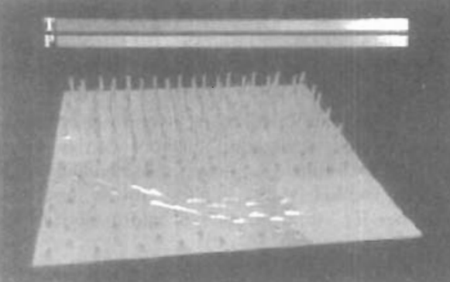
Visualization of a multivariate data field using a-glyph structure at selected grid positions

